EPA
I’ll rebuild the EPA main entrance, but priority will be the map. Critters can come later. They require a more complex creative process, (designing, modeling, texturing, animating, and rendering). Let’s create a beautiful and faithful world first. A layout that is credible is ‘critical’, so I’ll be sending a basic visual idea of building placements and scale. Please feel free to show them to the interested parties come up with a consensus. Following Continuum’s Submarine Mod Forum its obvious people can be very passionate about Fallout. Feel free to change and improve any layout, but once we start building stick to the design. That’s why the initial design is the most critical phase. Personally I believe whatever 3rd party assets that are built must fit in naturally with the original concept behind Fallout, as well as the original artistic vision. After saying that, I have no problem collaborating with others to make this game even greater.
Dropping epawrhse.map was a wise choice. I found it a confusing location. But what about the scientist there, is he gone? Do you have an objection if I bring some vegetation from Arcanum into the EPA? Whatever plant life it is I’ll blend it into the Fallout vision.


The above critter was used in Arcanum. It displays certain plantlike qualities (mushroom actually). I could bring him into the EPA as an extra nasty critter!! The clean version is a straight copy from Arcanum; the other is my dirtier Fallout version. Scales wise it is larger than the original carnivorous plant critter, as well there are colour variations, which could be designed as different level critters i.e. (golden and silver geckos).
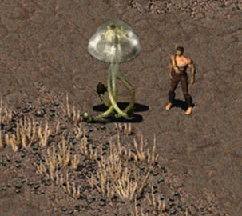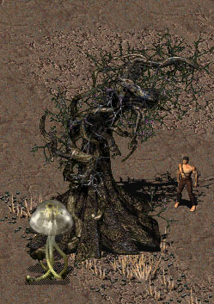
This is only a test critter. I built an animated FRM (without a shadow) as an example of its potential.
Plant wise I could introduce some of the trees from Arcanum into the EPA. Personally I feel because the two games were built by many of the same people, some of the ‘natural’ artwork blends in well into the Fallout universe. Others might disagree. But I would only use these pieces in the EPA, and nowhere else.
Killap there is a mention of a green house. There are two possibilities here. First: I use the original artwork, and try to arrange it in an interesting way. Second: Build completely new scenery and roof tiles that actually look like a greenhouse. With the second choice all of the assets I build would have to be sent to you to be made into “proto’s”. With all the game assets the proto files must be in order, etc. The Restoration Project has already its own proto lists and anything extra built into the game must go in order on the end of those lists. I have practically filled up all of the unused scenery and tile slots that were available in Fallout 2, so anything new must be sent to you, prototyped, and then sent back. So in your next email I need confirmation on your preference. Build new scenery or stick with the old.
Is it possible to write a filter for Photoshop that slices images into tile size pieces? It would make life much easier.
I will build new walls by using reconstructing old elements. Eg. The clean vault walls had a N\S window wall, but the old vault walls did not. I simply build an old window wall in Photoshop. The same for the NCR wall pillar. All this can be used in the new EPA.
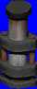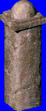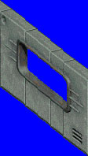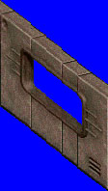

EPA Layout
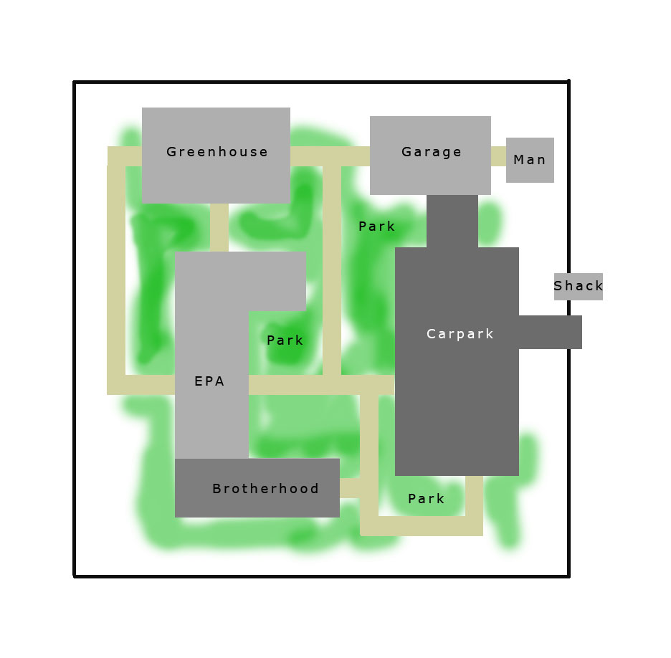

This is my basic concept. Please feel free to alter anything. But get back to me quickly, because slow email responses will slow this project down. Just copy the image into Photoshop and draw over the image with your changes, then email it back to me.

